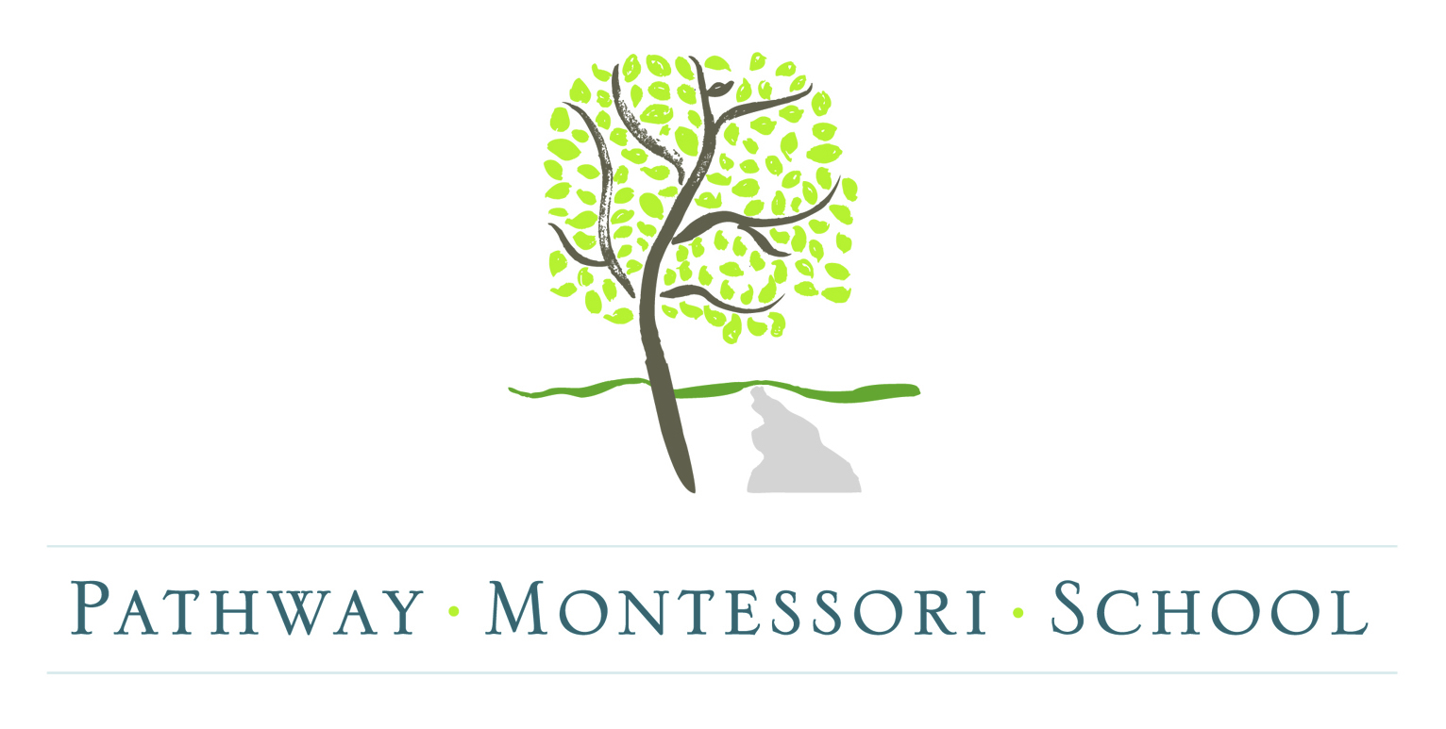
P.O. Box 7283.Tupelo.MS.38802-7283
662.678.3008
pathwaymontessori@gmail.com

APPLICATION FOR ADMISSION
Child’s Full Name______________________________________________Nickname___________________________
Date of Birth___________________Present Age (Years & Months) ______________________ Male or Female
Home Address______________________________________________________________________________________
Allergies: Yes (please explain) ____________________________________________________________ No
____________________________________________________________________________________________
Mother’s Name________________________________________________________Home Phone___________________
Address (if different)_________________________________________________________________________________
Employer_______________________________________________Occupation/Position__________________________
Cell Phone__________________Work Phone___________________Email_____________________________________
Is there a special interest that could be shared in the classroom? Yes_________________________________ No

Father’s Name________________________________________________________Home Phone___________________
Address (if different)_________________________________________________________________________________
Employer_______________________________________________Occupation/Position__________________________
Cell Phone__________________Work Phone___________________Email_____________________________________
Is there a special interest that could be shared in the classroom? Yes_________________________________ No

Siblings’ Names & Ages______________________________________________________________________________
Has your child ever attended day care? Yes (Where?)______________________________________________ No
Why are you considering Montessori for your child? __________________________________________________________________________________________________
How many days a week: 2 (T/TH) _____ 3(M/W/F) _____ 5(M/T/W/TH/F) _____

- Is there any physical, emotional, or psychological information that might influence your child’s behavior or developmental growth?

___________________________________________________________________________________________

___________________________________________________________________________________________

___________________________________________________________________________________________

- What do you hope your child will gain from attending Pathway Montessori School?

___________________________________________________________________________________________

___________________________________________________________________________________________

___________________________________________________________________________________________

- Please give us any information on your child’s daily schedule (typical awakening times, toilet habits, how you help your child when he/she is upset or sad, eating routines, etc.) that will help us serve your child better:

___________________________________________________________________________________________

___________________________________________________________________________________________

___________________________________________________________________________________________

___________________________________________________________________________________________

___________________________________________________________________________________________

___________________________________________________________________________________________

___________________________________________________________________________________________

- What do you as parents hope that Pathway Montessori can do for you?

___________________________________________________________________________________________

___________________________________________________________________________________________
___________________________________________________________________________________________

- Race/Ethnicity (optional):

_____Hispanic _____African-American _____Caucasian _____Asian _____Other

Pathway Montessori School is a non-discriminatory, non-sectarian school. The school has a non-discriminatory policy relative to race, color, religion, and national or ethnic origin with respect to the admissions, programs, and activities performed at the school as well as in regards to employment of faculty and staff.

Pathway Montessori School considers the records of all students to be confidential information available to a child’s parents or guardians upon request. Records will only be released to other schools or agencies upon receipt of a signed request from a parent or guardian, and only after all accounts are paid in full.

Parent/Guardian Signature___________________________________________________Date______________________

